REDES NEURONAL CONVOLUCIONAL

Link del Codigo: www.google.com

Nota:
epoch = 5

epoch 1: 153s - loss: 0.4512 - acc: 0.8362
epoch 2: 132s - loss: 0.3011 - acc: 0.8896
epoch 3: 128s - loss: 0.2567 - acc: 0.9046
epoch 4: 136s - loss: 0.2234 - acc: 0.9158
epoch 5: 145s - loss: 0.1970 - acc: 0.9262

Test Loss:
6s 618us/sample - loss: 0.2512 - acc: 0.9139

1. Visualización de las convoluciones y el pooling

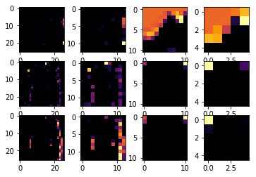

2. Variaciones en los items de las convoluciones

Variacion a 16:

Epoch 1/5 40s 674us/sample - loss: 0.9498 - acc: 0.6460
Epoch 2/5 39s 651us/sample - loss: 0.6360 - acc: 0.7580
Epoch 3/5 39s 649us/sample - loss: 0.5524 - acc: 0.7904
Epoch 4/5 39s 648us/sample - loss: 0.5044 - acc: 0.8117
Epoch 5/5 39s 649us/sample - loss: 0.4719 - acc: 0.8250

Testt: 3s 278us/sample - loss: 0.4799 - acc: 0.8253
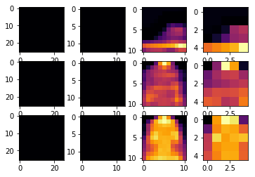

Variacion a 32:

Epoch 1/5 65s 1ms/sample - loss: 0.9088 - acc: 0.6601
Epoch 2/5 59s 979us/sample - loss: 0.6393 - acc: 0.7574
Epoch 3/5 62s 1ms/sample - loss: 0.5491 - acc: 0.7914
Epoch 4/5 66s 1ms/sample - loss: 0.5014 - acc: 0.8119
Epoch 5/5 64s 1ms/sample - loss: 0.4702 - acc: 0.8254

Test: 4s 356us/sample - loss: 0.4753 - acc: 0.8294

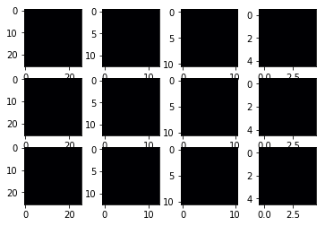

3. Eliminación de la convolucion final

Test para 64:

Epoch 1/5 134s 2ms/sample - loss: 0.8914 - acc: 0.6833
Epoch 2/5 137s 2ms/sample - loss: 0.5590 - acc: 0.7936
Epoch 3/5 143s 2ms/sample - loss: 0.4885 - acc: 0.8233
Epoch 4/5 136s 2ms/sample - loss: 0.4451 - acc: 0.8407
Epoch 5/5 135s 2ms/sample - loss: 0.4169 - acc: 0.8512

Test Loss: 4s 439us/sample - loss: 0.4369 - acc: 0.8443

4. Incremento de convoluciones

Test para 64:
Epoch 1/5 143s 2ms/sample - loss: 1.1199 - acc: 0.5711
Epoch 2/5 137s 2ms/sample - loss: 0.7377 - acc: 0.7210
Epoch 3/5 138s 2ms/sample - loss: 0.6604 - acc: 0.7523
Epoch 4/5 139s 2ms/sample - loss: 0.6132 - acc: 0.7697
Epoch 5/5 139s 2ms/sample - loss: 0.5819 - acc: 0.7821

Test loss: 6s 642us/sample - loss: 0.5856 - acc: 0.7860

5. Eliminacion de todas las convoluciones

Epoch 1/5 10s 164us/sample - loss: 0.4933 - acc: 0.8256
Epoch 2/5 9s 145us/sample - loss: 0.3695 - acc: 0.8671
Epoch 3/5 9s 146us/sample - loss: 0.3342 - acc: 0.8787
Epoch 4/5 9s 146us/sample - loss: 0.3085 - acc: 0.8879
Epoch 5/5 9s 148us/sample - loss: 0.2929 - acc: 0.8919

Test Loss: 1s 69us/sample - loss: 0.3742 - acc: 0.8663

6. Implementacion del callback

Para un accuracy del 93%

Epoch 1/10
60000/60000 [==============================] - 144s 2ms/sample - loss: 0.4417 - acc: 0.8408
Epoch 2/10
60000/60000 [==============================] - 137s 2ms/sample - loss: 0.2949 - acc: 0.8920
Epoch 3/10
60000/60000 [==============================] - 139s 2ms/sample - loss: 0.2476 - acc: 0.9080
Epoch 4/10
60000/60000 [==============================] - 138s 2ms/sample - loss: 0.2182 - acc: 0.9187
Epoch 5/10
60000/60000 [==============================] - 139s 2ms/sample - loss: 0.1914 - acc: 0.9287
Epoch 6/10
59968/60000 [============================>.] - ETA: 0s - loss: 0.1679 - acc: 0.9365

Se Alcanzó el 93% de precisión
60000/60000 [==============================] - 136s 2ms/sample - loss: 0.1679 - acc: 0.9365

Test Loss: 6s 630us/sample - loss: 0.2533 - acc: 0.9122
